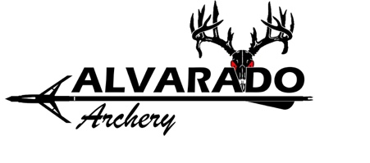
MEDIA RELEASE
I, the undersigned, hereby give my consent for Alvarado Archery INC to use my likeness, statements, voice and sound as a promotion for the company’s business.
I, personally and on behalf of my heirs, personal representatives, successors and assigns, do hereby release, waive, discharge and covenant not to sue Alvarado Archery INC, its officers, shareholders, employees, successors and assigns from any or all claims regarding the use of my likeness, statements, voice and sound, including, without limitation, claims for compensation, defamation or invasion of privacy or other infringements or violations of personal or property rights of any sort whatsoever that I may now or hereafter have against Alvarado Archery INC or any related party thereto.
I understand that any pictures, video, writings and audio obtained by Alvarado Archery INC in analog or digital form, can and will be used for commercial purposes. These purposes include – but are not limited to – publications online, in print, in promotional materials or on product packaging, audio-visual materials, use in broadcast television, films or audio and video available for viewing or downloading via the Internet. Furthermore, I understand and consent that Alvarado Archery INC may allow third-parties to use the pictures, video, writings and audio for similar purposes and further consent that Alvarado Archery INC may receive compensation from such third-parties for authorized use.
I freely give this authorization without expectation of compensation, even in the event that Alvarado Archery INC receives compensation from a third-party for the use of my likeness, statements, voice and sound.
SIGNING OF THIS RELEASE CONSTITUTES A CERTIFCATION THAT THE UNDERSIGNED HAS READ AND FULLY UNDERSTANDS THIS MEDIA RELEASE FORM.
Signature_________________________________________
Date__________________________________
Printed name _____________________________________________________________________________

Parent / guardian printed name (If under age 18) __________________________________________________________
Parent /guardian signature (If under age 18) ______________________________________________________________
Relationship to Participant _____________________________
Date __________________________________________

Alvarado Archery, Inc. | www.Alvaradoarchery.com | 817-783-7300 | 6011 E Hwy 67 Alvarado, TX
