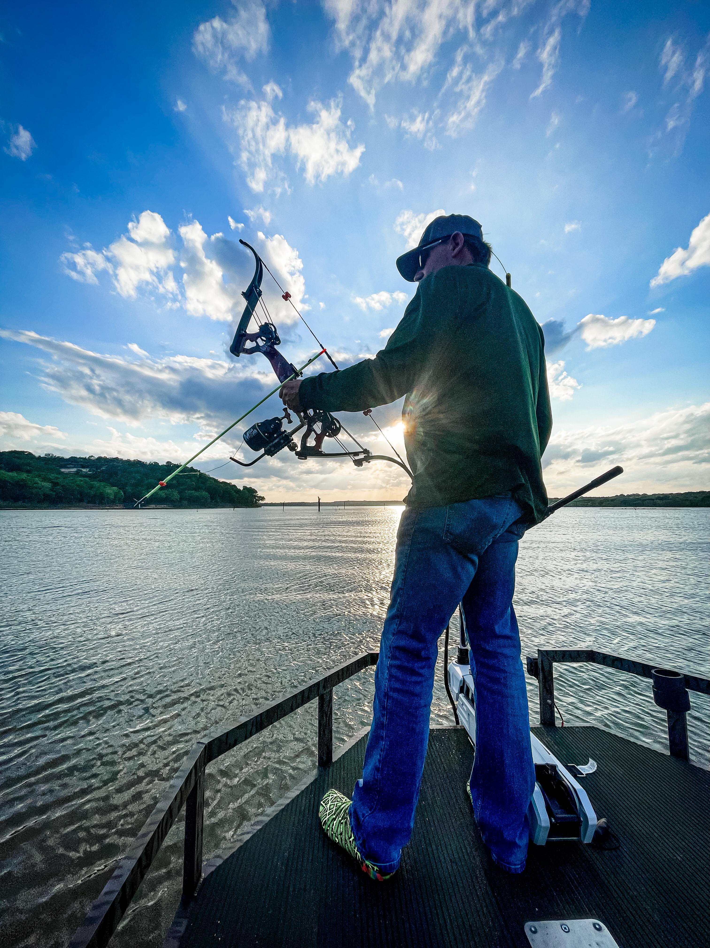  - March-may ‘23  bowfishing tournament series  6 lake championship bowfishing tournament  Fish 6 lakes (TBD), accumulate points toward championship, 25% payout to winner of each event, 65% of entry fees from each of 6 events goes to a pot for winner of tournament series championship. Must fish 2 of 6 lakes plus final lake to be eligible for championship.  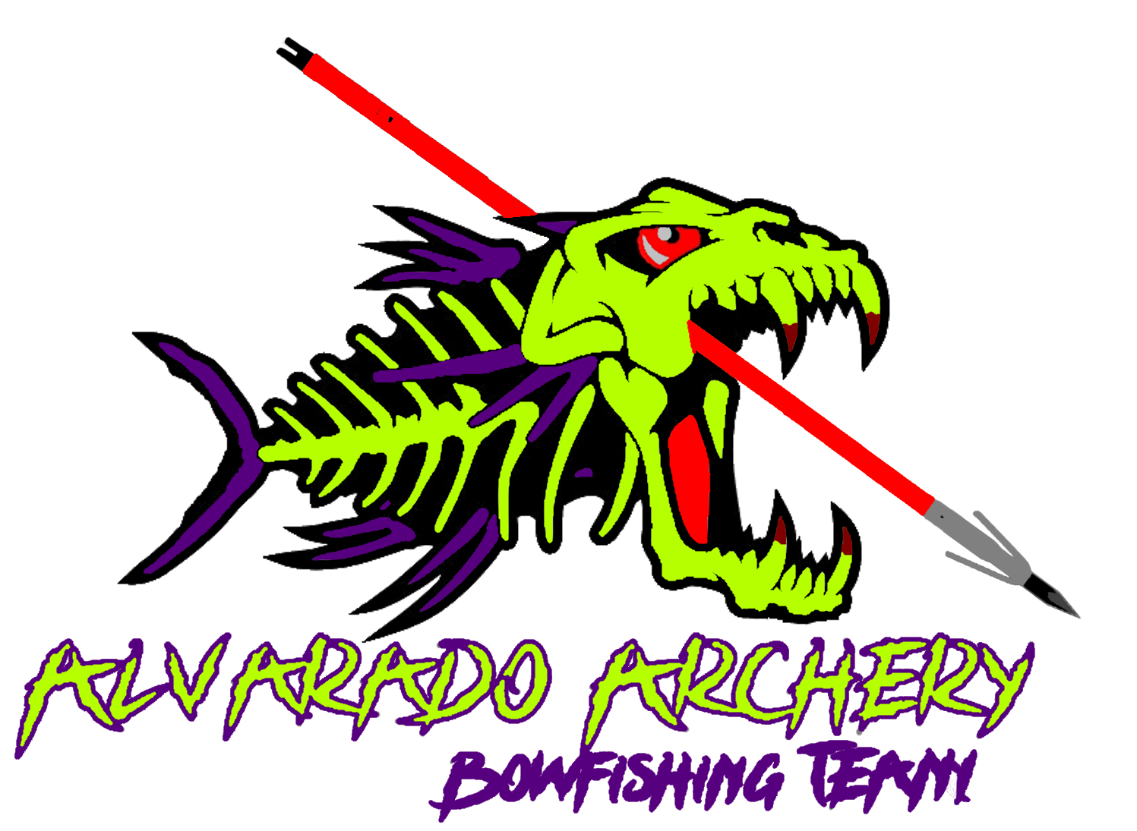 | 6 Lake Tournament Championship Bowfishing Series  ____  March – May $150 entry fee per team per event  ____  Potential to win over $10,000  ____  Accumulate points each event toward championship  ____  Points leader takes $ of combined pots from 6 events  Alvarado archery  6011 E Hwy 67  Alvarado, Tx 76009  817-783-7300  www.Alvaradoarchery.com  March-May 2023

